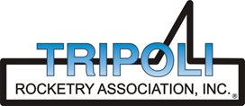
Tripoli Motor Testing Division
223 NC Highway 54 West
Chapel Hill, NC 27514
(919) 357 5681 (c)
January 8, 2023

Gary Rosenfield
RCS Rocket Motor Components, Inc.
2113 West 850 North Street
Cedar City, UT 84721

Dear Mr. Rosenfield,

The Aerotech M2225WS-PS reload kit was tested on January 7, 2023 and complies with NFPA 1125. The motor is certified for hobby rocketry use by the members of the Tripoli Rocketry Association and all approving organizations with reciprocal certifying agreements.

Motor Manufacturer RCS Rocket Motor Components, Inc.
Manufacturer’s Designation M2225WS-PS [For the 75/5120 case]
Propellant Super White Lightning
TMT Nomenclature 5205 M2239

Diameter 2.958” 75.13 mm
Overall Length 27.234” 691.75 mm
Outside the MMT 1.703” 43.26 mm

Loaded Mass 10.35 lb 4694.7 g
Propellant Mass 5.139 lb* 2331 g*
Burnout Mass 4.950 lb 2245.3 g
* = data provided by manufacturer

Burn time 2.323 sec

Total Impulse 1171.2 lbf.s 5205 N.s
Max Impulse 543.68 lbf 2418.4 N
Average Impulse 503.39 lbf 2239.2 N
Number of Motors Tested 2

Nominal Measured
Delay Time Data n.a. n.a.

Casing Temp. [NFPA 1125 7.4.1] Passed

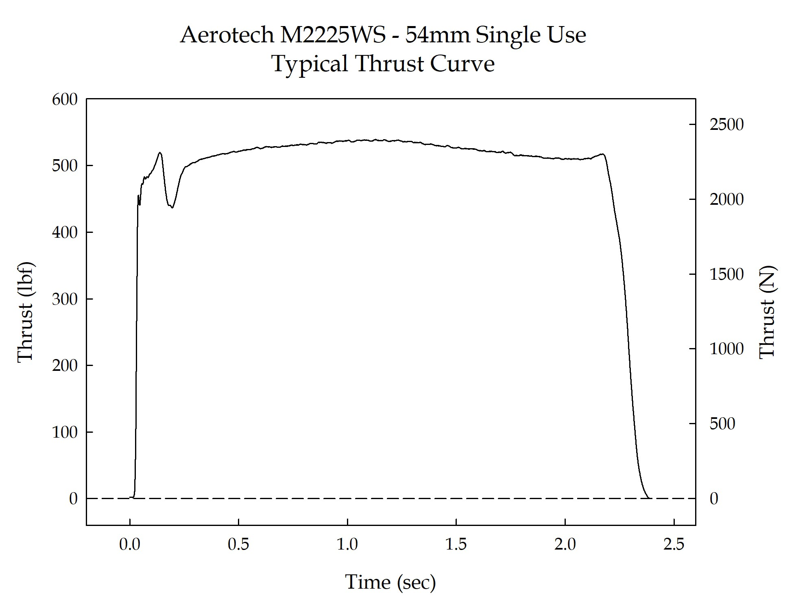

Sincerely,

Alan C. Whitmore
Chair, Tripoli Motor Testing

